Current status and needs of Thayne Senior Center

Recent announcements have stated Lincoln County is one of the fastest growing counties in WY, since the 2020 census, the announcement shows an increase of 5.5% in population. Currently, the Thayne Senior Center serves over 1,300 registered clients in the Lower Valley region. The number of meals served annually has increased by over 300% since 1998. The Center is currently preparing and delivering approximately 800 meals each month to homebound seniors in addition to those served at the center. Approximately 11,000-15,000 meals are served annually in the dining room setting with indoor seating for 80. During the summer months outdoor seating is provided to increase dining capacity.

The current building where the senior center is now located is in a shared space owned by the Town of Thayne, which is approximately 5,300 square feet; TSC has access to approximately 2,650 square feet, 345 square feet used by the kitchen. There are 62 parking spaces now, with several of those reserved for town clients.

The current center is bursting at the seams and lacks space for current services; needs for a proposed center:
-Adequate covered entry way for safe access to the center
-Adequate handicap parking, adequate parking spaces
-Additional square footage for commercial kitchen
-Additional refrigerator and freezer space, currently we only have space for 1 weeks’ worth of food
-Safe access for volunteers to meals for home delivered service
-Additional square footage for dining room
-Private meeting rooms for medical services
-Indoor storage space for medical checkout devices
-Private meeting rooms for senior consultations (ie. medicare insurance dietary needs recommendations, health education programs, etc)
-Additional rooms for physical activities and community programs

The current plans for the Lower Valley Regional Human Services facility now include the flexibility of adding/changing private rooms, negative air flow ventilation, air exchangers, adequate floor space with separate ingress/egress for volunteers to access food for delivery, additional space for food pantry box storage for our home-bound clients, inside clean, dry storage of loanable medical equipment (walkers, wheelchairs, crutches, toilet risers), community health services, evidence based health education and exercise programs, foot clinics provided by professionals, and space for telehealth appointments. The aging community needs a safe and adequate space to keep them healthy and active.

Additional, adequate space as well as funding is needed to allow for continual lifelong learning, physical exercise, sleep, meditation, diet, socialization and volunteering, among other factors which are beneficial to every community member.

A larger facility will be a huge asset, not only for seniors and their families, but the entire community. The lower valley needs a large meeting place for community gatherings and intergenerational programs. The facility will also be a great place for community education and resources in addition to space for exercise classes and emergency preparedness. This facility will provide increased community interactions and a safe space for active living. It will make a huge impact on our growing community for the next 30-50 years. This will be a place that everyone can gather, build social connections and support one another and the aging population.
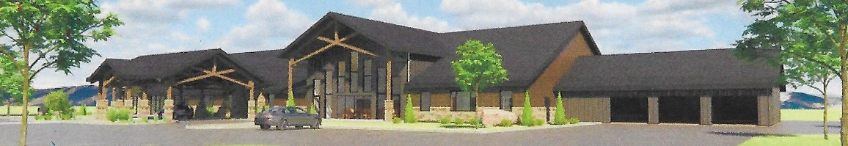
For more information or to donate visit our website at www.thaynesenior.com

